LAB 01

A national retail company operates in multiple regions and provinces and sells products from different categories. The company stores its monthly transactions in a data warehouse and wants a basic dashboard for management decision-making.
You are hired as a Junior Data Analyst. Your job is to:
- Write SQL queries to extract the required data
- Create correct charts (visualizations) from the query results

Task 1: Regional Sales Performance
SQL: Find total sales by REGION (highest to lowest).
SELECT
g.REGION_NAME,
SUM(s.SALES) AS TOTAL_SALES
FROM AV.SALES_FACT s
JOIN AV.GEOGRAPHY_DIM g
ON s.STATE_PROVINCE_ID = g.STATE_PROVINCE_ID
GROUP BY g.REGION_NAME
ORDER BY TOTAL_SALES DESC;

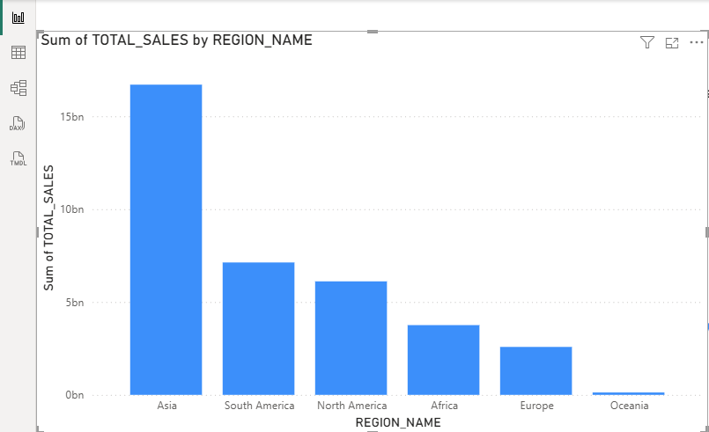
Visualization: Create a Bar Chart

Task 2: Category Sales Performance
SQL: Find total sales by CATEGORY.
SELECT
p.CATEGORY_NAME,
SUM(s.SALES) AS TOTAL_SALES
FROM AV.SALES_FACT s
JOIN AV.PRODUCT_DIM p
ON s.CATEGORY_ID = p.CATEGORY_ID
GROUP BY p.CATEGORY_NAME
ORDER BY TOTAL_SALES DESC;

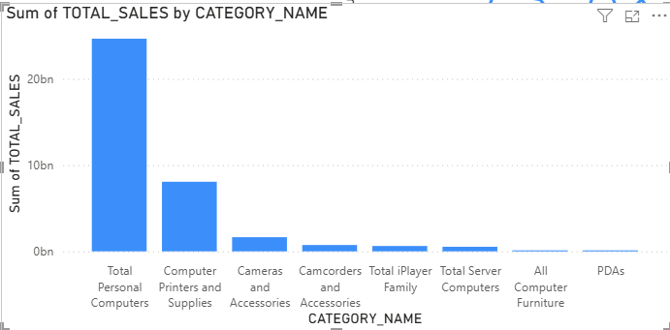
Visualization: Create a Column Chart

Task 3: Monthly Sales Trend
SQL: Find total monthly sales trend (Year + Month order).
SELECT
t.YEAR_ID,
t.MONTH_ID,
t.MONTH_NAME,
SUM(s.SALES) AS TOTAL_SALES
FROM AV.SALES_FACT s
JOIN AV.TIME_DIM t
ON s.MONTH_ID = t.MONTH_ID
GROUP BY t.YEAR_ID, t.MONTH_ID, t.MONTH_NAME
ORDER BY t.YEAR_ID, t.MONTH_ID;

Visualization: Create a Line Chart.
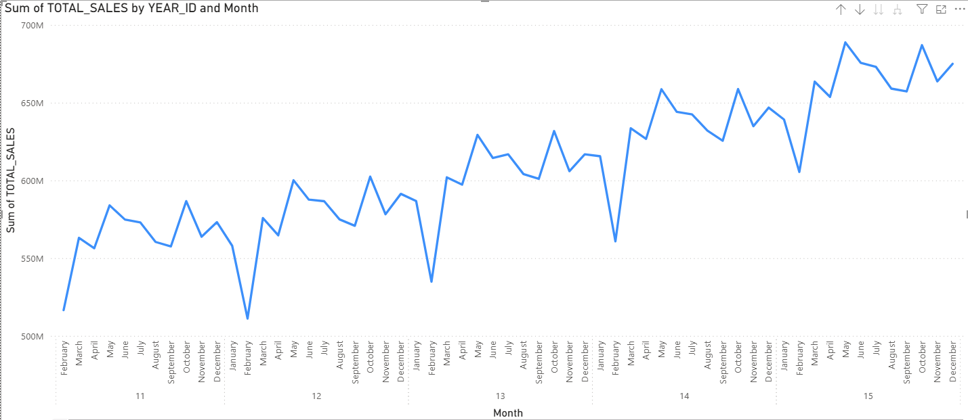

Task 4: Monthly Units Trend
SQL: Find total monthly units sold trend (Year + Month order).
SELECT
t.YEAR_ID,
t.MONTH_ID,
t.MONTH_NAME,
SUM(s.UNITS) AS TOTAL_UNITS
FROM AV.SALES_FACT s
JOIN AV.TIME_DIM t
ON s.MONTH_ID = t.MONTH_ID
GROUP BY t.YEAR_ID, t.MONTH_ID, t.MONTH_NAME
ORDER BY t.YEAR_ID, t.MONTH_ID;

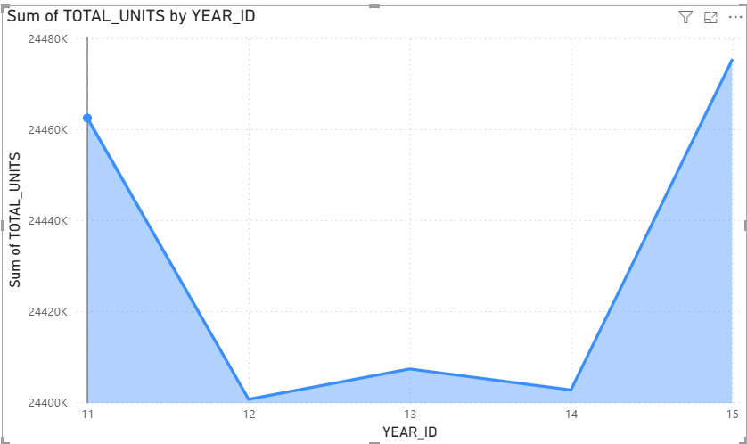
Visualization: Create an Area Chart.

Task 5: Region vs Category Sales (Stacked)
SQL: Find sales grouped by REGION and CATEGORY.
SELECT
g.REGION_NAME,
p.CATEGORY_NAME,
SUM(s.SALES) AS TOTAL_SALES
FROM AV.SALES_FACT s
JOIN AV.GEOGRAPHY_DIM g
ON s.STATE_PROVINCE_ID = g.STATE_PROVINCE_ID
JOIN AV.PRODUCT_DIM p
ON s.CATEGORY_ID = p.CATEGORY_ID
GROUP BY g.REGION_NAME, p.CATEGORY_NAME
ORDER BY g.REGION_NAME, TOTAL_SALES DESC;

Visualization: Create a Stacked Bar Chart
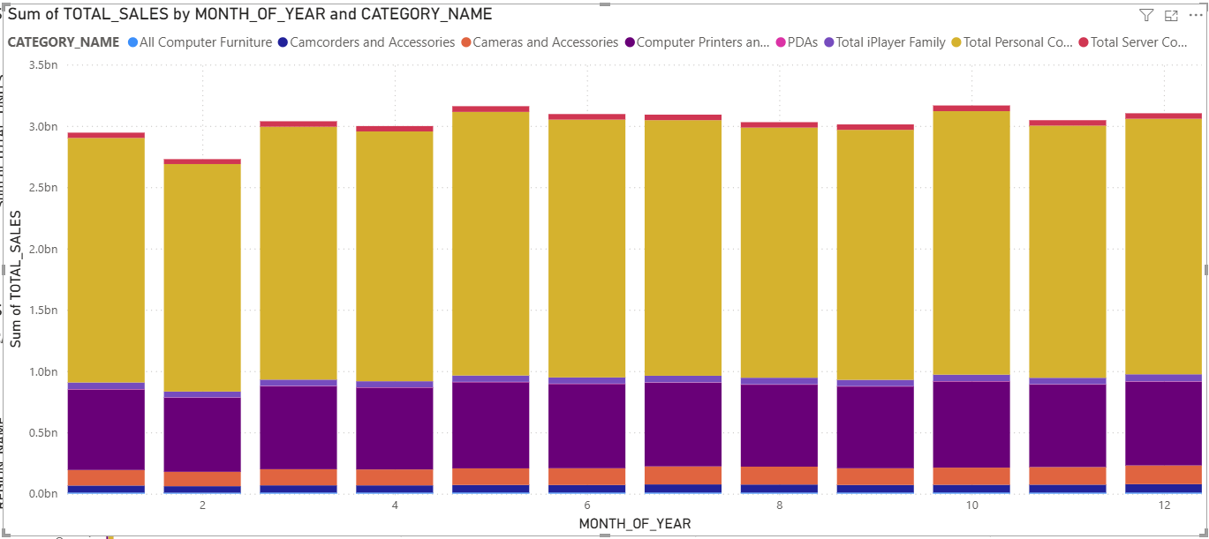

Task 6: Month vs Category Sales (Stacked)
SQL: Find sales grouped by MONTH and CATEGORY.
SELECT
t.YEAR_ID,
t.MONTH_NAME,
p.CATEGORY_NAME,
SUM(s.SALES) AS TOTAL_SALES
FROM AV.SALES_FACT s
JOIN AV.TIME_DIM t
ON s.MONTH_ID = t.MONTH_ID
JOIN AV.PRODUCT_DIM p
ON s.CATEGORY_ID = p.CATEGORY_ID
GROUP BY t.YEAR_ID, t.MONTH_ID, t.MONTH_NAME, p.CATEGORY_NAME
ORDER BY t.YEAR_ID, t.MONTH_ID;

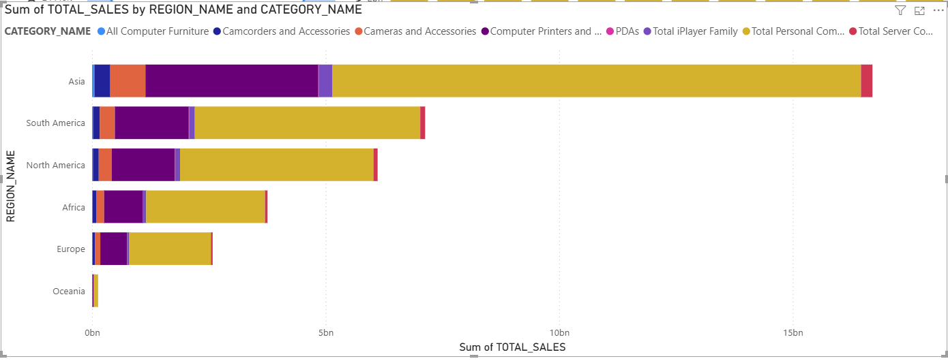
Visualization: Create a Stacked Column Chart

Task 7: Sales vs Units by Category
SQL: Return total SALES and total UNITS by category.
SELECT
p.CATEGORY_NAME,
SUM(s.SALES) AS TOTAL_SALES,
SUM(s.UNITS) AS TOTAL_UNITS
FROM AV.SALES_FACT s
JOIN AV.PRODUCT_DIM p
ON s.CATEGORY_ID = p.CATEGORY_ID
GROUP BY p.CATEGORY_NAME
ORDER BY TOTAL_SALES DESC;

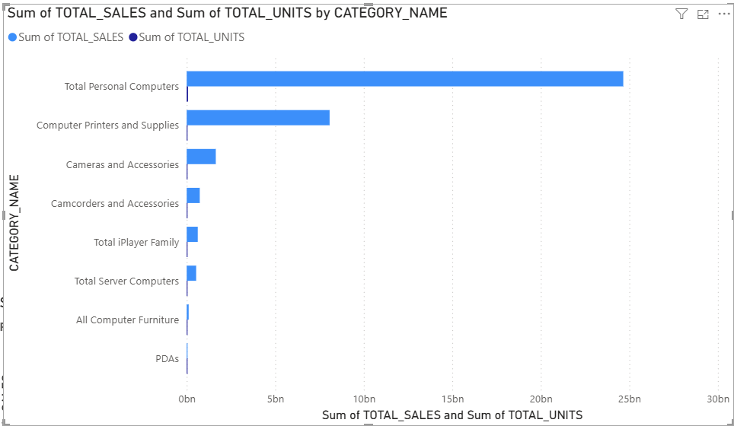
Visualization: Create a Clustered Bar Chart

Task 8: Monthly Sales by Region (Clustered)
SQL: Return monthly sales grouped by MONTH and REGION.
SELECT
t.YEAR_ID,
t.MONTH_NAME,
g.REGION_NAME,
SUM(s.SALES) AS TOTAL_SALES
FROM AV.SALES_FACT s
JOIN AV.TIME_DIM t
ON s.MONTH_ID = t.MONTH_ID
JOIN AV.GEOGRAPHY_DIM g
ON s.STATE_PROVINCE_ID = g.STATE_PROVINCE_ID
GROUP BY t.YEAR_ID, t.MONTH_ID, t.MONTH_NAME, g.REGION_NAME
ORDER BY t.YEAR_ID, t.MONTH_ID;

Visualization: Create a Clustered Column Chart
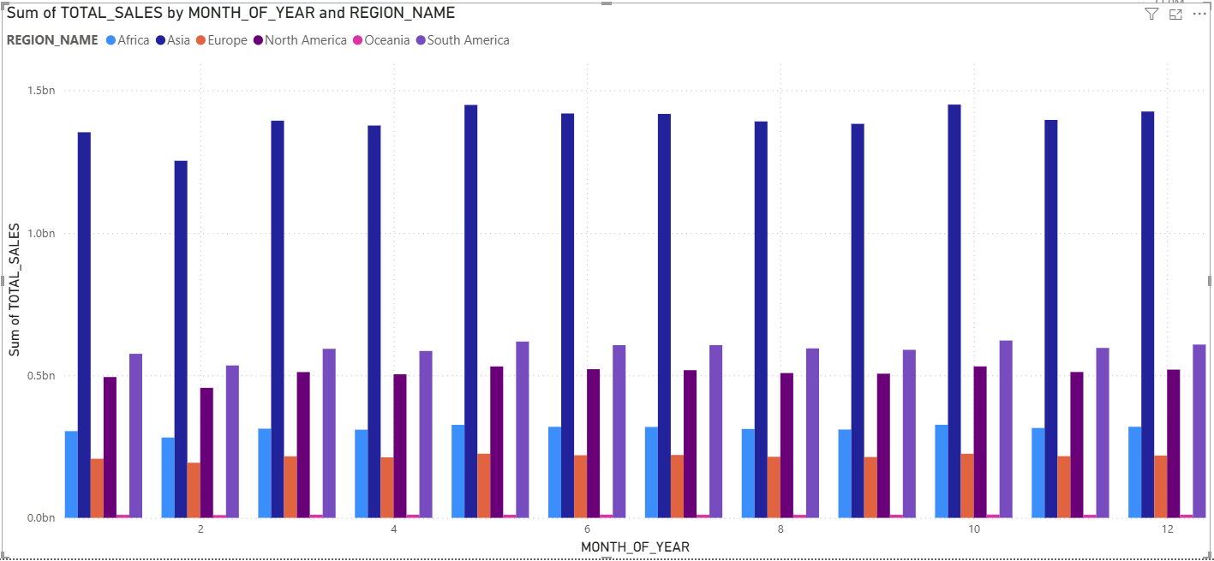

Task 9: Combo Chart (Sales + Units)
SQL: Return monthly sales and units together.
SELECT
t.YEAR_ID,
t.MONTH_NAME,
SUM(s.SALES) AS TOTAL_SALES,
SUM(s.UNITS) AS TOTAL_UNITS
FROM AV.SALES_FACT s
JOIN AV.TIME_DIM t
ON s.MONTH_ID = t.MONTH_ID
GROUP BY t.YEAR_ID, t.MONTH_ID, t.MONTH_NAME
ORDER BY t.YEAR_ID, t.MONTH_ID;

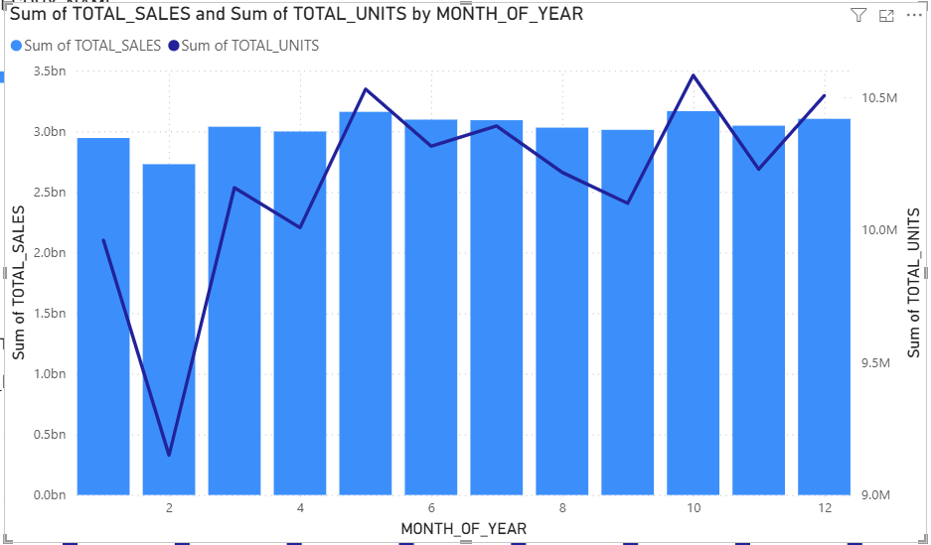
Visualization: Create a Line &amp; Column Combo Chart

Task 10: Province-Level Sales Trend
SQL: Filter monthly sales for a specific STATE_PROVINCE (e.g., Sindh).
SELECT
t.YEAR_ID,
t.MONTH_NAME,
SUM(s.SALES) AS TOTAL_SALES
FROM AV.SALES_FACT s
JOIN AV.TIME_DIM t
ON s.MONTH_ID = t.MONTH_ID
JOIN AV.GEOGRAPHY_DIM g
ON s.STATE_PROVINCE_ID = g.STATE_PROVINCE_ID
WHERE UPPER(g.STATE_PROVINCE_NAME) = 'SINDH'
GROUP BY t.YEAR_ID, t.MONTH_ID, t.MONTH_NAME
ORDER BY t.YEAR_ID, t.MONTH_ID;

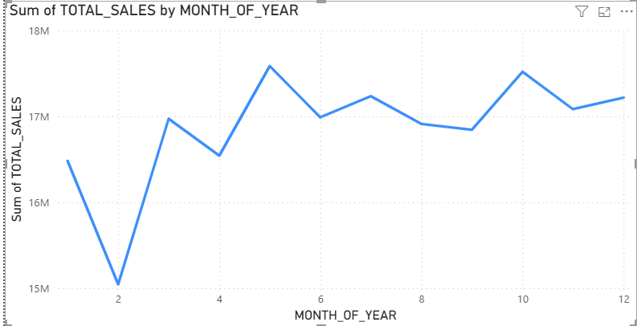
Visualization: Create a Line Chart (Month vs Sales) for that province.

Task 11: Region-wise Sales Contribution
Write an SQL query to calculate total sales by region and the percentage contribution of each region to overall sales, sorted in descending order of total sales. Create an appropriate visualization for the result.
SELECT
g.REGION_NAME,
SUM(s.SALES) AS TOTAL_SALES,
ROUND(
SUM(s.SALES) * 100 /
SUM(SUM(s.SALES)) OVER (),
2
) AS SALES_PERCENTAGE
FROM AV.SALES_FACT s
JOIN AV.GEOGRAPHY_DIM g
ON s.STATE_PROVINCE_ID = g.STATE_PROVINCE_ID
GROUP BY g.REGION_NAME
ORDER BY TOTAL_SALES DESC;

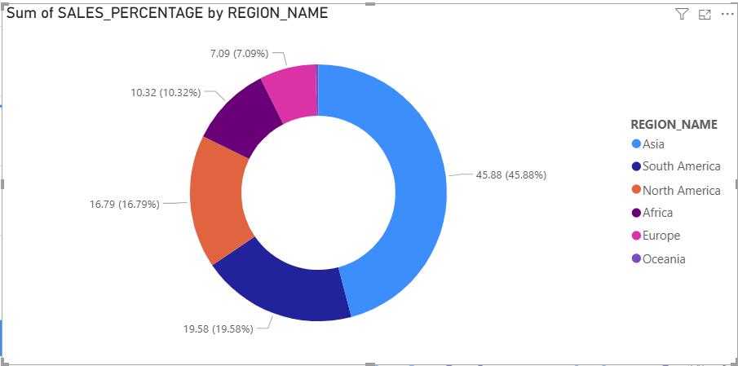

Task 12: Top Categories by Sales Performance
Write an SQL query to identify the top five product categories based on total sales, including total units sold for each category. Create an appropriate visualization for comparison.
SELECT *
FROM (
SELECT
p.CATEGORY_NAME,
SUM(s.SALES) AS TOTAL_SALES,
SUM(s.UNITS) AS TOTAL_UNITS
FROM AV.SALES_FACT s
JOIN AV.PRODUCT_DIM p
ON s.CATEGORY_ID = p.CATEGORY_ID
GROUP BY p.CATEGORY_NAME
ORDER BY TOTAL_SALES DESC
)
WHERE ROWNUM <= 5;

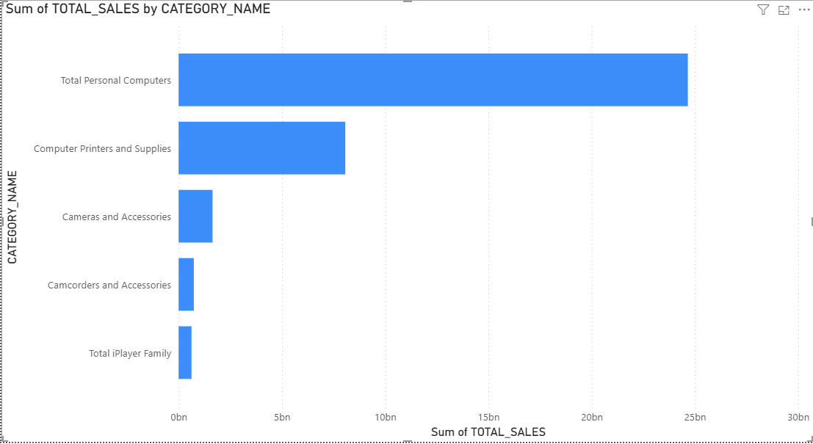

Task 13: Monthly Sales Trend with Rolling Analysis
Write an SQL query to display monthly total sales along with a three-month rolling average, ordered by year and month. Create an appropriate visualization to represent the trend.
SELECT
t.YEAR_ID,
t.MONTH_ID,
t.MONTH_NAME,
SUM(s.SALES) AS MONTHLY_SALES,
ROUND(
AVG(SUM(s.SALES)) OVER (
ORDER BY t.YEAR_ID, t.MONTH_ID
ROWS BETWEEN 2 PRECEDING AND CURRENT ROW
),
2
) AS ROLLING_AVG_3_MONTHS
FROM AV.SALES_FACT s
JOIN AV.TIME_DIM t
ON s.MONTH_ID = t.MONTH_ID
GROUP BY t.YEAR_ID, t.MONTH_ID, t.MONTH_NAME
ORDER BY t.YEAR_ID, t.MONTH_ID;

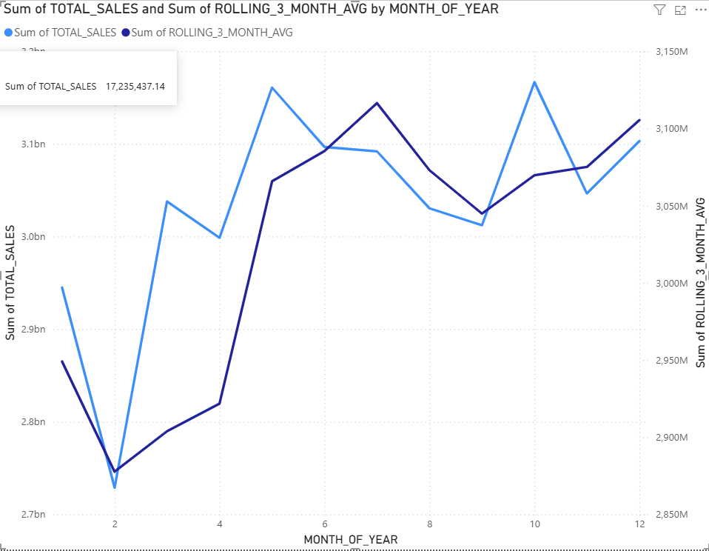

Task 14: Monthly Units Trend and Change Analysis
Write an SQL query to show monthly total units sold and the month-over-month change in units. Create an appropriate visualization to highlight variations over time.
SELECT
t.YEAR_ID,
t.MONTH_ID,
t.MONTH_NAME,
SUM(s.UNITS) AS TOTAL_UNITS,
SUM(s.UNITS) -
LAG(SUM(s.UNITS)) OVER (ORDER BY t.YEAR_ID, t.MONTH_ID)
AS MOM_CHANGE
FROM AV.SALES_FACT s
JOIN AV.TIME_DIM t
ON s.MONTH_ID = t.MONTH_ID
GROUP BY t.YEAR_ID, t.MONTH_ID, t.MONTH_NAME
ORDER BY t.YEAR_ID, t.MONTH_ID;

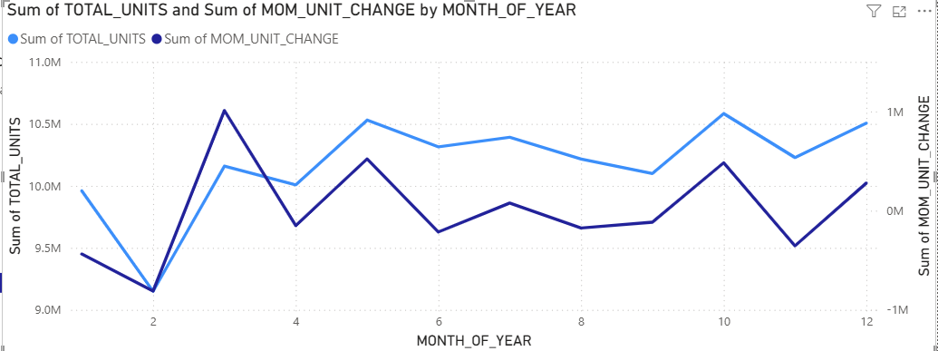

Task 15: Regional Category Dominance Analysis
Write an SQL query to find the top two product categories within each region based on total sales using ranking or window functions. Create an appropriate visualization to compare regional dominance.
SELECT *
FROM (
SELECT
g.REGION_NAME,
p.CATEGORY_NAME,
SUM(s.SALES) AS TOTAL_SALES,
RANK() OVER (
PARTITION BY g.REGION_NAME
ORDER BY SUM(s.SALES) DESC
) AS RNK
FROM AV.SALES_FACT s
JOIN AV.GEOGRAPHY_DIM g
ON s.STATE_PROVINCE_ID = g.STATE_PROVINCE_ID
JOIN AV.PRODUCT_DIM p
ON s.CATEGORY_ID = p.CATEGORY_ID
GROUP BY g.REGION_NAME, p.CATEGORY_NAME
)
WHERE RNK <= 2;

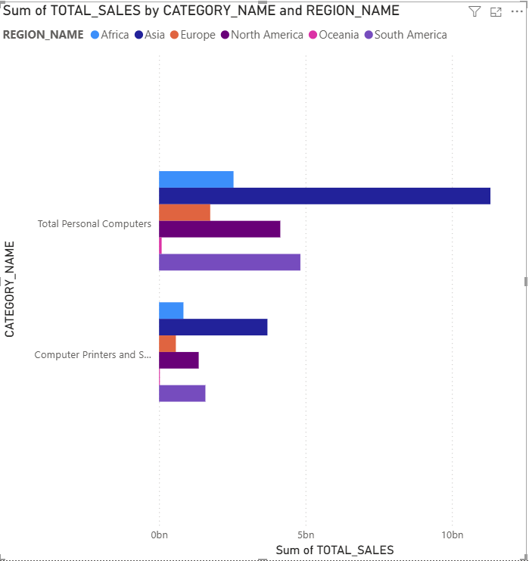

Task 16: Month vs Category Sales (Latest Year)
Write an SQL query to return monthly sales grouped by product category for the most recent year available in the dataset. Create an appropriate visualization to show monthly category contributions.
SELECT
t.MONTH_NAME,
p.CATEGORY_NAME,
SUM(s.SALES) AS TOTAL_SALES
FROM AV.SALES_FACT s
JOIN AV.TIME_DIM t
ON s.MONTH_ID = t.MONTH_ID
JOIN AV.PRODUCT_DIM p
ON s.CATEGORY_ID = p.CATEGORY_ID
WHERE t.YEAR_ID = (
SELECT MAX(YEAR_ID) FROM AV.TIME_DIM
)
GROUP BY t.MONTH_ID, t.MONTH_NAME, p.CATEGORY_NAME
ORDER BY t.MONTH_ID;

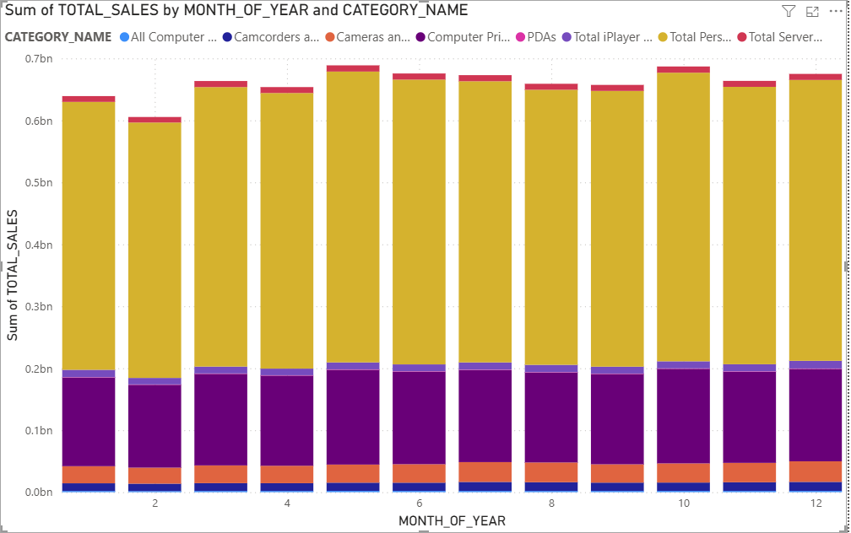

Task 17: Category-wise Average Selling Price Analysis
Write an SQL query to calculate the Average Selling Price (ASP) for each product category (ASP = Total Sales / Total Units), ensuring safe handling of division by zero. Create an appropriate visualization to compare ASP across categories.
SELECT
p.CATEGORY_NAME,
SUM(s.SALES) AS TOTAL_SALES,
SUM(s.UNITS) AS TOTAL_UNITS,
ROUND(
SUM(s.SALES) / NULLIF(SUM(s.UNITS), 0),
2
) AS AVERAGE_SELLING_PRICE
FROM AV.SALES_FACT s
JOIN AV.PRODUCT_DIM p
ON s.CATEGORY_ID = p.CATEGORY_ID
GROUP BY p.CATEGORY_NAME
ORDER BY AVERAGE_SELLING_PRICE DESC;

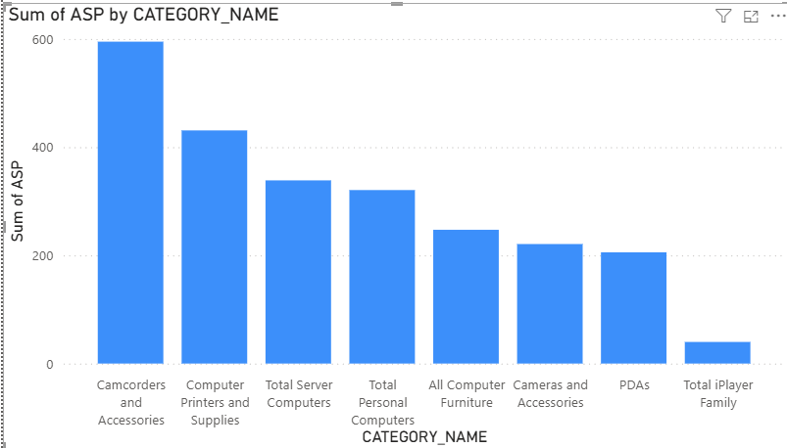

Task 18: Month vs Region Sales (Top Regions)
Write an SQL query to display monthly sales by region, restricted to the top three regions based on overall sales. Create an appropriate visualization to compare regional trends.
SELECT
t.YEAR_ID,
t.MONTH_NAME,
g.REGION_NAME,
SUM(s.SALES) AS TOTAL_SALES
FROM AV.SALES_FACT s
JOIN AV.TIME_DIM t
ON s.MONTH_ID = t.MONTH_ID
JOIN AV.GEOGRAPHY_DIM g
ON s.STATE_PROVINCE_ID = g.STATE_PROVINCE_ID
WHERE g.REGION_NAME IN (
SELECT REGION_NAME
FROM (
SELECT
g.REGION_NAME,
SUM(s.SALES) AS TOTAL_SALES
FROM AV.SALES_FACT s
JOIN AV.GEOGRAPHY_DIM g
ON s.STATE_PROVINCE_ID = g.STATE_PROVINCE_ID
GROUP BY g.REGION_NAME
ORDER BY TOTAL_SALES DESC
)
WHERE ROWNUM <= 3
)
GROUP BY t.YEAR_ID, t.MONTH_ID, t.MONTH_NAME, g.REGION_NAME
ORDER BY t.YEAR_ID, t.MONTH_ID;

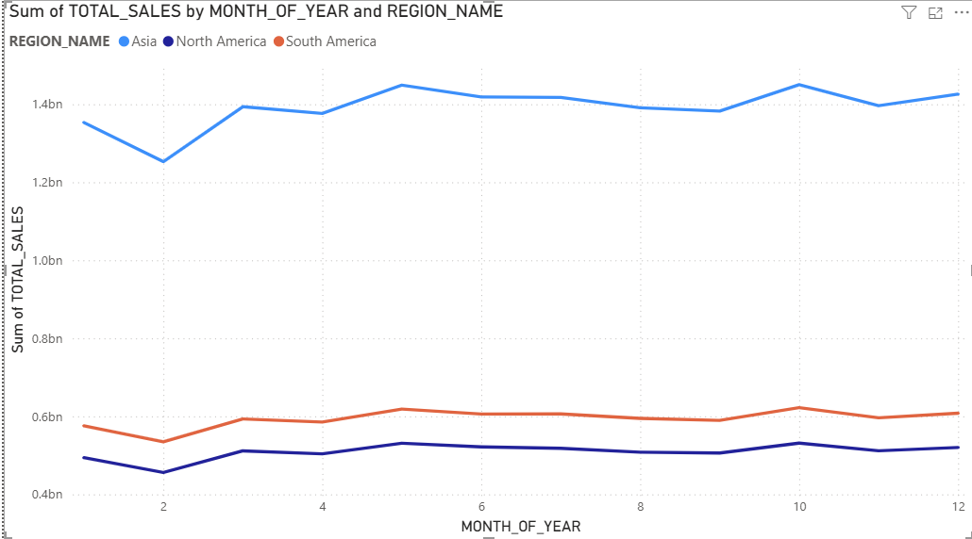

Task 19: Monthly Sales, Units, and Growth Analysis
Write an SQL query to return monthly sales, monthly units, and monthly sales growth percentage compared to the previous month. Create an appropriate visualization to represent value, volume, and growth together.
SELECT
t.YEAR_ID,
t.MONTH_ID,
t.MONTH_NAME,
SUM(s.SALES) AS TOTAL_SALES,
SUM(s.UNITS) AS TOTAL_UNITS,
ROUND(
(SUM(s.SALES) -
LAG(SUM(s.SALES)) OVER (ORDER BY t.YEAR_ID, t.MONTH_ID))
/ LAG(SUM(s.SALES)) OVER (ORDER BY t.YEAR_ID, t.MONTH_ID) * 100,
2
) AS SALES_GROWTH_PERCENT
FROM AV.SALES_FACT s
JOIN AV.TIME_DIM t
ON s.MONTH_ID = t.MONTH_ID
GROUP BY t.YEAR_ID, t.MONTH_ID, t.MONTH_NAME
ORDER BY t.YEAR_ID, t.MONTH_ID;

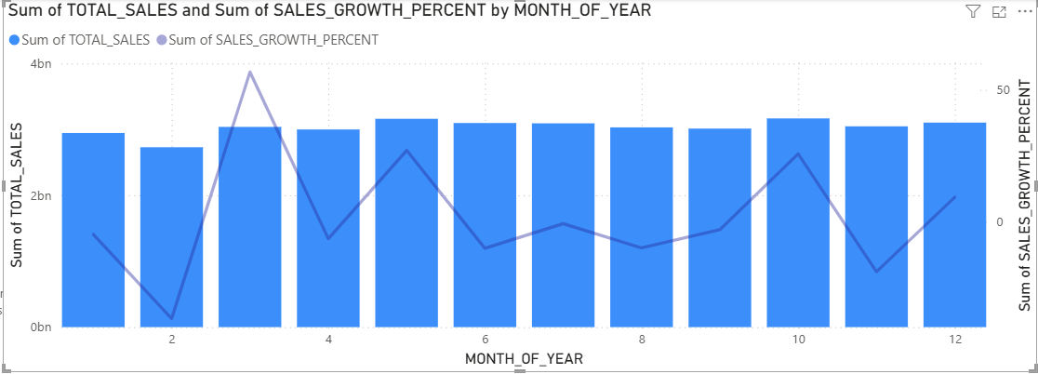

Task 20: Province-wise Monthly Sales Ranking Analysis
Write an SQL query to show monthly sales for a selected province (e.g., Sindh) and its rank among all provinces for each month based on sales. Create an appropriate visualization to show performance and ranking trends.
SELECT *
FROM (
SELECT
t.YEAR_ID,
t.MONTH_NAME,
g.STATE_PROVINCE_NAME,
SUM(s.SALES) AS TOTAL_SALES,
RANK() OVER (
PARTITION BY t.YEAR_ID, t.MONTH_ID
ORDER BY SUM(s.SALES) DESC
) AS PROVINCE_RANK
FROM AV.SALES_FACT s
JOIN AV.TIME_DIM t
ON s.MONTH_ID = t.MONTH_ID
JOIN AV.GEOGRAPHY_DIM g
ON s.STATE_PROVINCE_ID = g.STATE_PROVINCE_ID
GROUP BY
t.YEAR_ID,
t.MONTH_ID,
t.MONTH_NAME,
g.STATE_PROVINCE_NAME
)
WHERE UPPER(STATE_PROVINCE_NAME) = 'SINDH'
ORDER BY YEAR_ID, MONTH_NAME;

